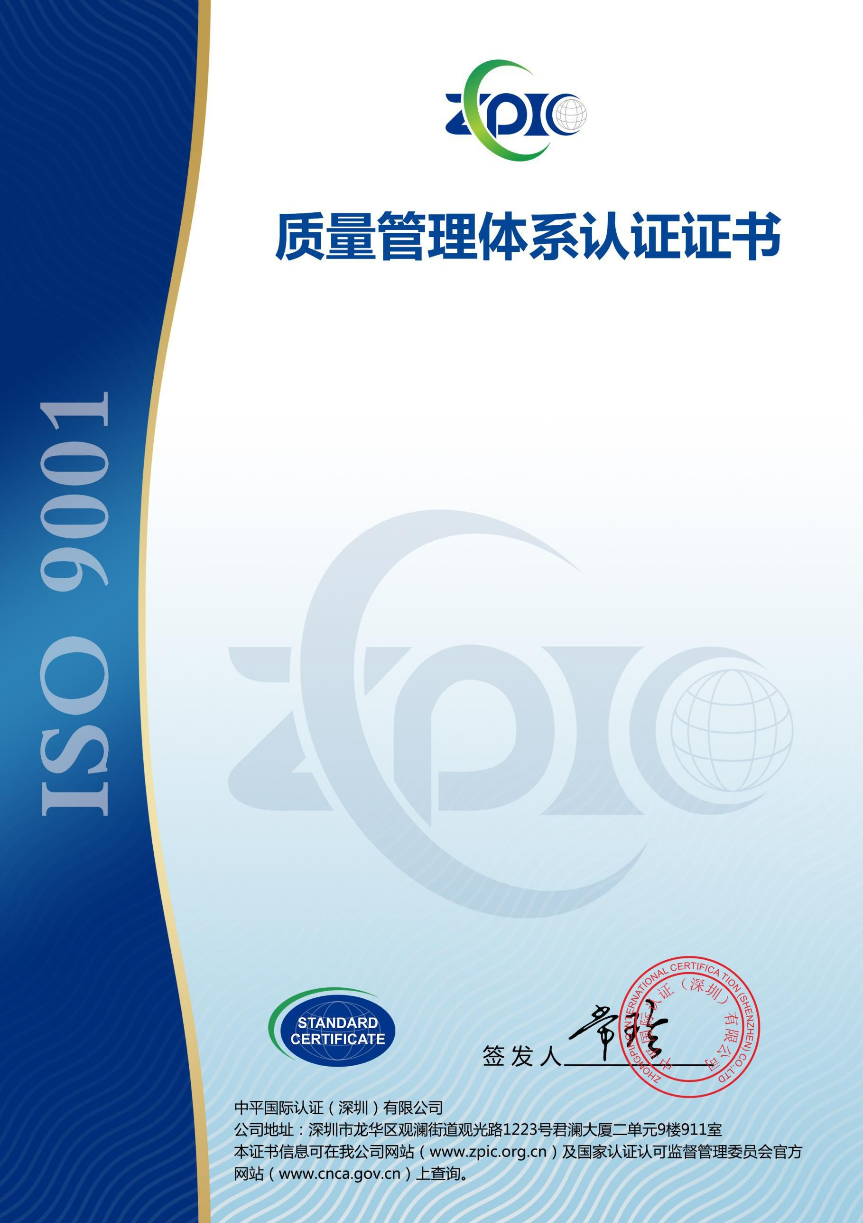

证书号：61120Q0178R0M

兹证明

# 深圳市创族智能实业有限公司

统一社会信用代码：91440300MA5ECUHY2A

注册地址：深圳市宝安区新安街道兴东社区 68 区隆昌路 10 号美生创谷夏谷 303A 经营地址：深圳市宝安区石岩街道水田社区石龙仔路东侧厂房 A 栋四层

# 质量管理体系符合标准GB/T19001-2016/ISO9001:2015

**认证范围**

**VR、平板电脑的组装（未取得 CCC、入网许可前不得内销）**

首次发证日期：2020 年 09 月 21 日 本次发证日期：2020 年 09 月 21 日

证书有效期至：2023 年 09 月 20 日

本证书的有效性需经中平国际认证通过定期的监督审核确认保持



第一次监督审核



第二次监督审核

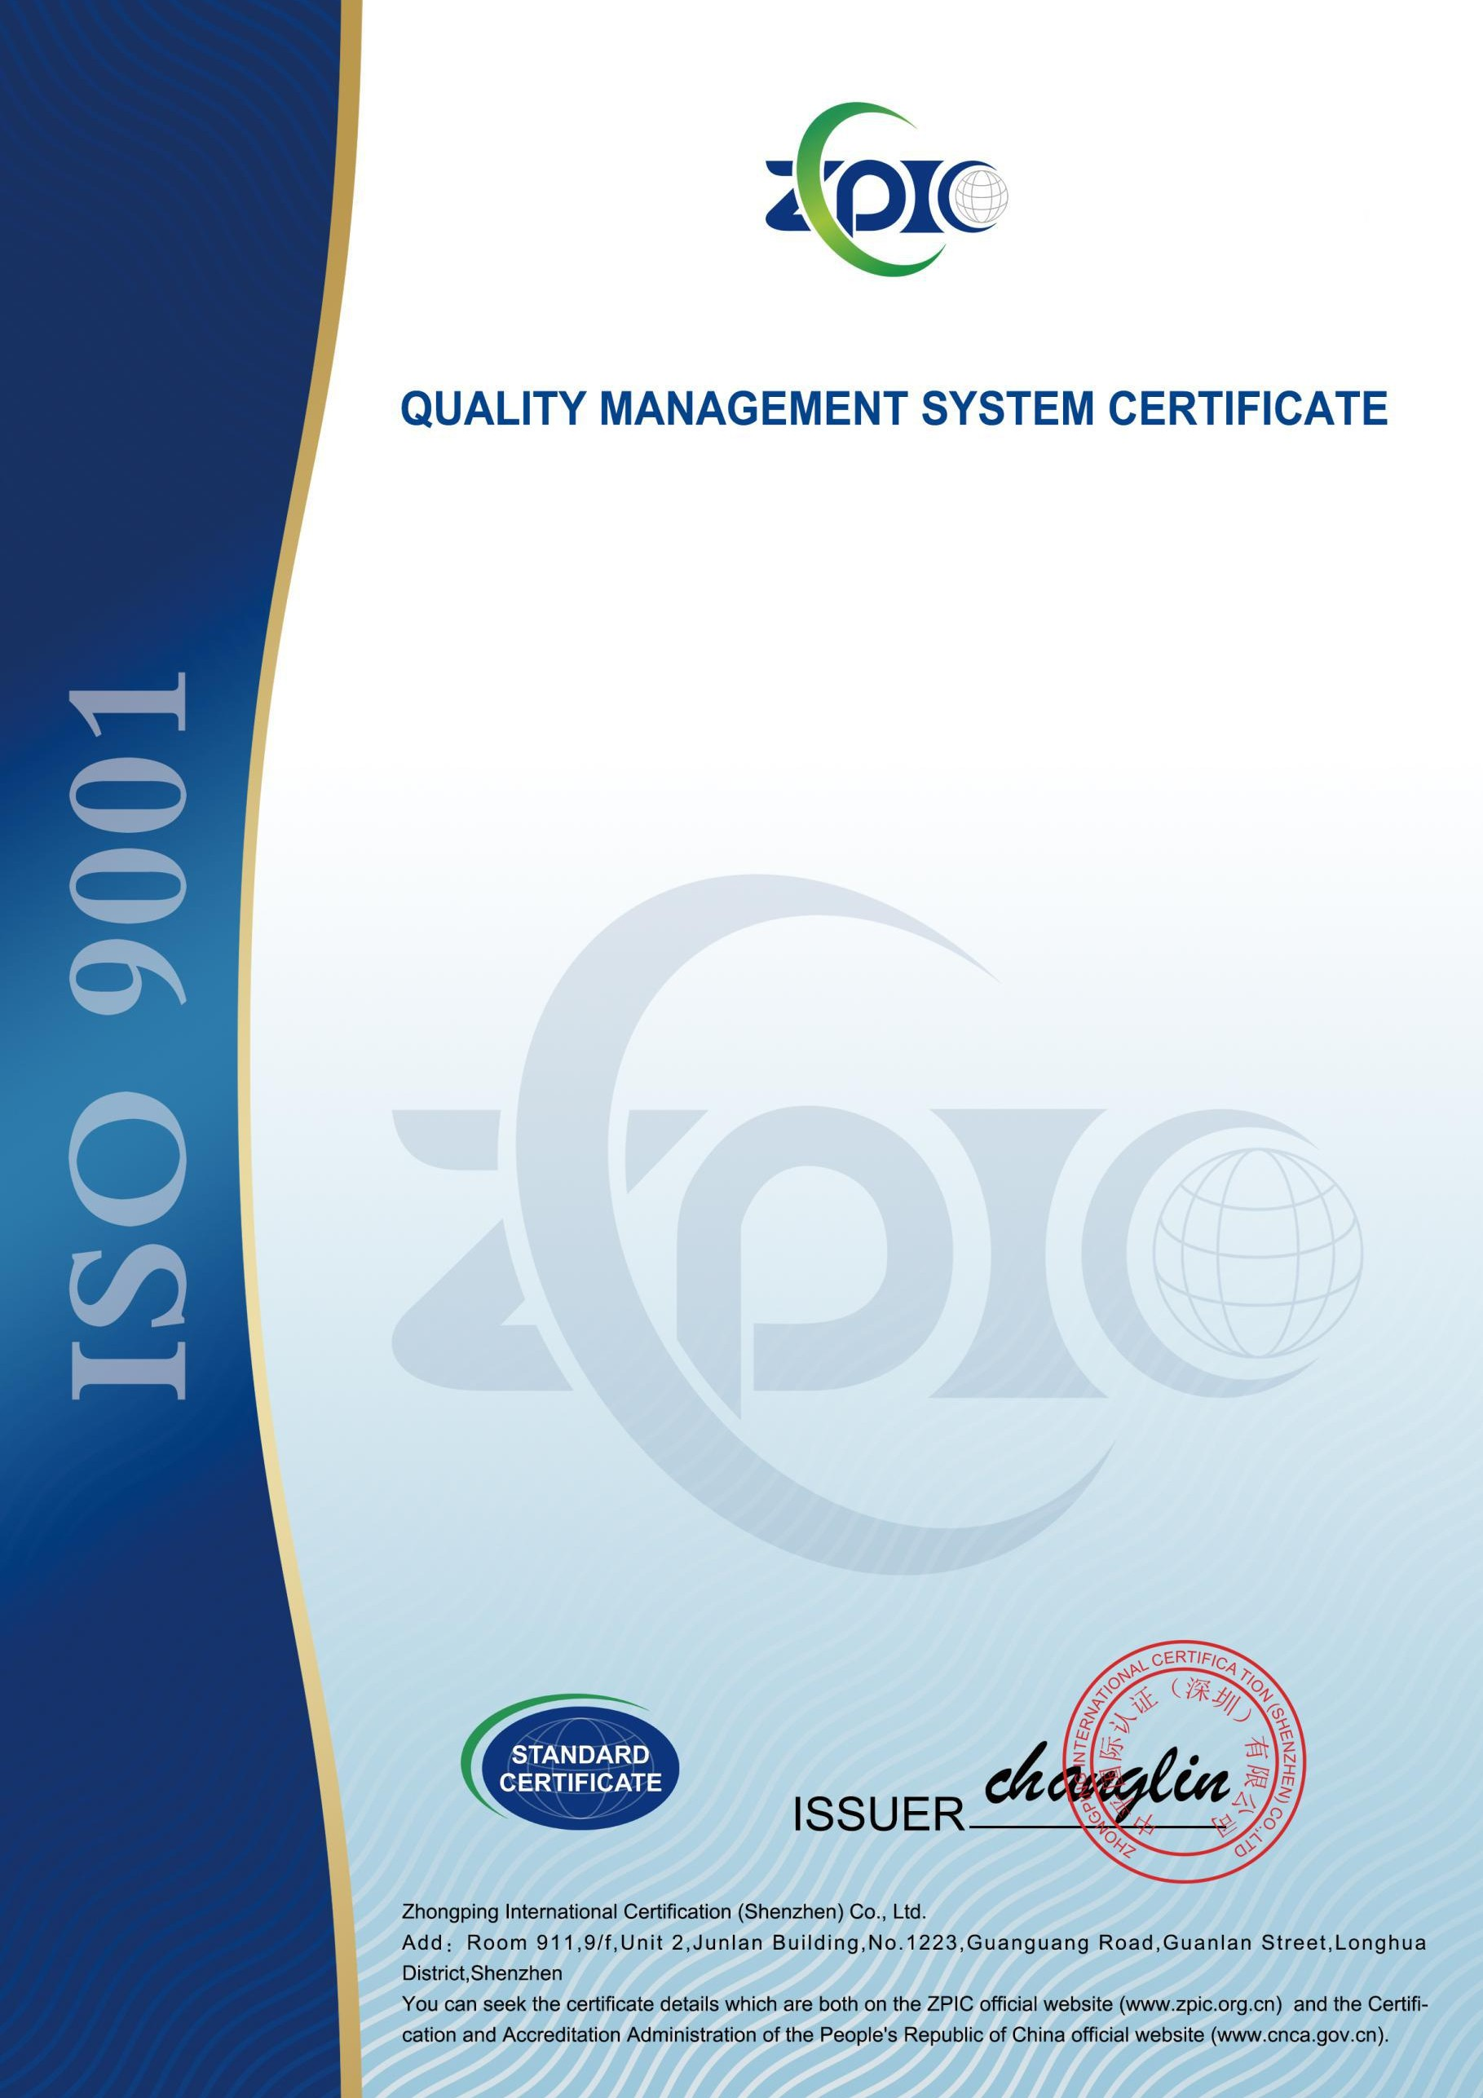

Certificate No.61120Q0178R0M This is to certify that

# Visionsky (SZ) Industrial Co., Ltd

Unified Social Credit Code:91440300MA5ECUHY2A

Registered address:303A, Xiagu, Meisheng Chuanggu, NO.10 Longchang RD, No.68 District Xingdong community, Xinan Street, Baoan District, Shenzhen

Business address:4F, Bldg A, East side factory, Shilongzai Road, Shuitian Community, Shiyan St, Baoan District, Shenzhen

# Which is in conformity with GB/T19001-2016/ISO9001:2015

Scope of certification VR, tablet computer assembly

(not to be sold in China without CCC and network access permission)

Issue Date:September 21,2020 Reissue Date:September 21,2020

Valid Until:September 20,2023

The effectiveness of this Certificate shall be validated by periodic audit of supervision of ZPIC for maintenance



First surveillance audit



Second surveillance audit